FASFEPA Fall Forum
March 5-7, 2024
Rosen Centre Hotel, Orlando
Sponsor Levels
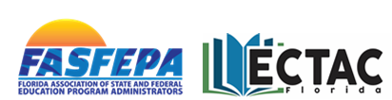

Platinum Level: $5,000
- 2 exhibit tables in premium location
- 4 company representative registrations
- podium recognition
- opportunity to address attendees (10-minute maximum) before a general session or lunch break
- 1 recorded video (3-5 minute maximum) presented on the SCHED agenda app and FASFEPA website
- company logo on single-page hardcopy Forum agenda
- company logo displayed on SCHED agenda app and the FASFEPA website for 30 days
- access to attendee email (pre and post Forum)
Gold Level: $3,000
- 1 exhibit table
- 2 company representative registrations
- podium recognition
- 1 recorded video (3-5 minute maximum) presented on the SCHED agenda app and FASFEPA website
- company logo displayed on SCHED agenda app and the FASFEPA website for 30 days
- access to attendee email (pre and post Forum)
Silver Level: $1,800
- 1 exhibit table
- 2 company representative registrations
- company logo displayed on SCHED agenda app and the FASFEPA website for 30 days
- access to attendee email (pre and post Forum)

Questions?
Contact Diane Dannemiller fasfepa@hotmail.com or Michael Kilts michael.kilts@jcsb.org

